Project Design Phase
Solution Architecture

Introduction
The SHOPEZ E-Commerce Application follows a modular MERN stack architecture that separates the presentation layer, application layer, and data layer. The architecture is designed to provide scalability, maintainability, security, and efficient communication between system components. The solution architecture illustrates how users interact with the frontend, how requests are processed by the backend, and how data is stored and retrieved from the database.
- System Architecture
Figure 1: Overall System Architecture of SHOPEZ E-Commerce Application
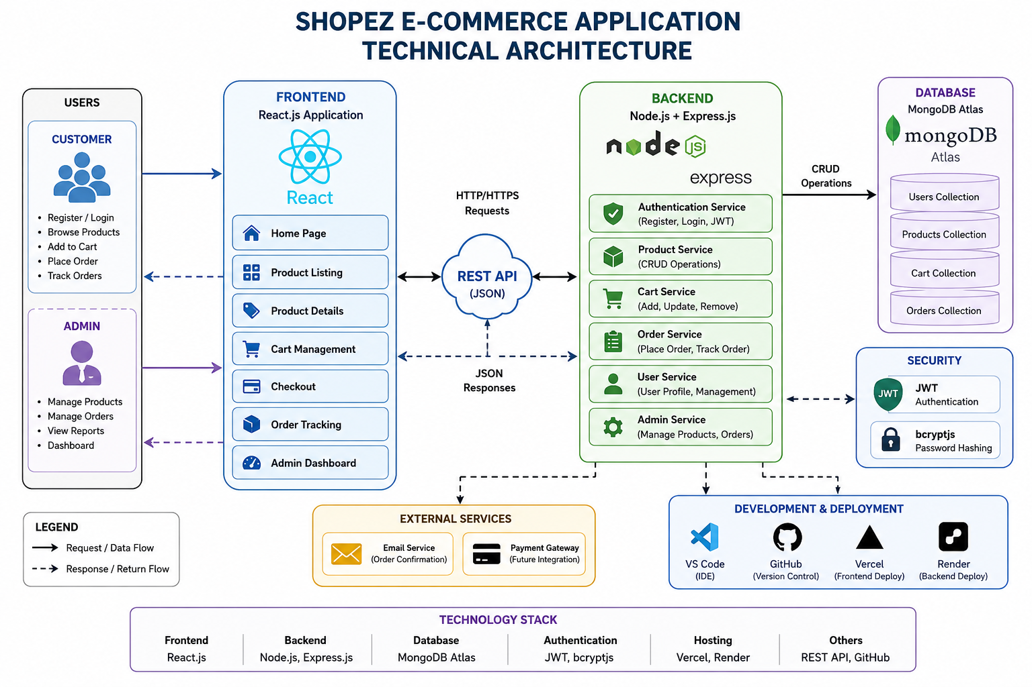

- Frontend Architecture

Figure 2: Frontend Architecture of SHOPEZ E-Commerce Application

User
│
▼
React.js Application
│
├── Home
├── Products
├── Product Details
├── Login
├── Register
├── Cart
├── Checkout
├── Orders
└── Admin Dashboard
│
▼
Components
│
├── Navbar
└── ProductCard

Description:
The frontend layer is developed using React.js and provides an interactive user interface for customers and administrators. It consists of reusable components and pages such as Home, Products, Product Details, Login, Register, Cart, Checkout, Orders, and Admin Dashboard. React Router DOM is used for navigation between pages.

- Backend Architecture

Figure 3: Backend Architecture of SHOPEZ E-Commerce Application

Client Requests
│
▼
Routes
│
▼
Controllers
│
▼
Models
│
▼
MongoDB Atlas

Modules:
- User Routes
- Product Routes
- Cart Routes
- Order Routes

Description:
The backend is developed using Node.js and Express.js. It handles user authentication, product management, cart operations, order processing, and API routing. JWT is used for authentication and bcryptjs is used for password encryption. The backend communicates with MongoDB Atlas using Mongoose.

- Database Design

Figure 4: Database Design of SHOPEZ E-Commerce Application

MongoDB Atlas
│
┌────────┼────────┐
│ │ │
▼ ▼ ▼

Users Products Orders

• userId • productId • orderId
• name • name • userId
• email • description • productId
• password • price • quantity
• role • category • totalAmount
• image • orderDate
• stock • status

Description:
The database layer is implemented using MongoDB Atlas. It stores application data including user information, product details, and order records. Mongoose schemas are used to define data structures and manage interactions between the application and database.

- ER Diagram

+---------+ +---------+
| USER | 1 ---- N| ORDER |
+---------+ +---------+
|
|
|1
|
N
+---------+
| CART |
+
|
|
N
|
1

| PRODUCT |

ADMIN
|
|
| manages
|
▼
PRODUCT

Relationship:

User 1 ─── N Orders
User 1 ─── N Cart Items
Product 1 ─── N Cart Items
Product 1 ─── N Orders
Admin 1 ─── N Products

- Conclusion
The solution architecture of the SHOPEZ E-Commerce Application provides a structured and scalable framework for implementing online shopping functionalities. By integrating React.js, Node.js, Express.js, and MongoDB Atlas, the system ensures efficient communication between components, secure authentication, organized data management, and a user-friendly experience. The architecture supports future enhancements while maintaining reliability, scalability, and maintainability.

